

2014

**South Park Database**

**Database Design Project**

**Mike McGinnis**

Table of Contents:

**Executive Summary**

**Overview**

South Park is a TV show that airs on Comedy Central. It has been on the air since 1997 and follows the adventures of four ten year old boys in the fictional town of South Park, Colorado. The show’s creators are Trey Parker, and Matt Stone. The two of them voice the majority of the male characters on the show. The show tackles current issues by parodying them in way that is both funny and thought provoking. There is no issue the show won’t tackle from religion, to politics. Keeping track of character information, what has already been parodied, and number of times Kenny has been killed (running gag), can lead to the creation of funnier episodes and ensures you don’t accidently parody something twice unintentionally.

**Objectives**

The purpose of this paper is to provide both fun and useful information about the show South Park. Since the boys are only ten, it is funny how much they curse, so there is a table to keep track of curses per character per episode. There is also a running gag that the character Kenny dies a lot so we’ll keep track of what episodes he dies in. To improve the show we will keep track of everything that has been parodied so far, this way if someone comes up with an idea for an episode they can quickly check to make sure they haven’t parodied it already.

**Entity Relationship Diagram**

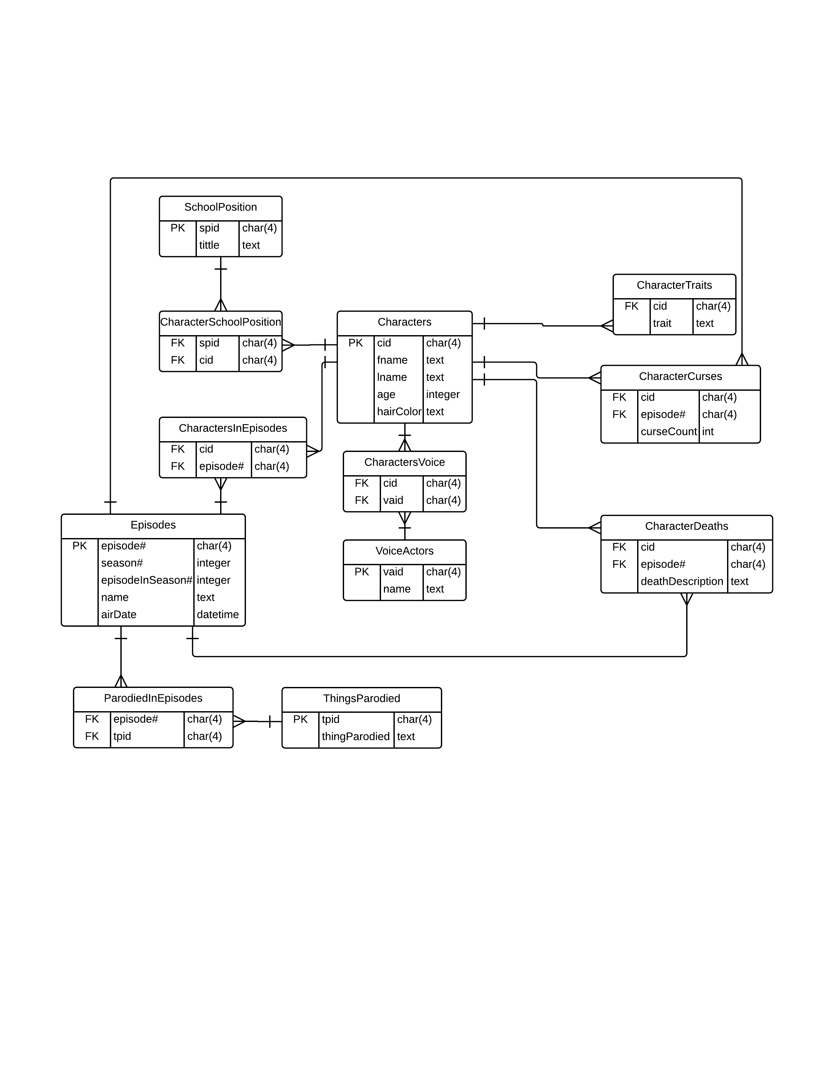

**Tables**

**Characters**

Purpose: This table is used to store information about the characters who appear in the show such as their name, age, and hair color.

**Create Statement**

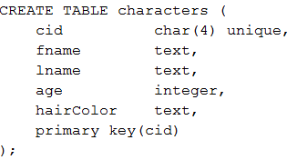

**Functional Dependencies**

cid 🡪 fname, lname, age, hairColor

**Sample Data**

|  |  |  |  |  |
| --- | --- | --- | --- | --- |
| CID | FName | LName | Age | HairColor |
| C001 | Stan | Marsh | 10 | Black |
| C002 | Kyle | Broflovski | 10 | Red |
| C003 | Kenny | McCormick | 10 | Blond |
| C004 | Eric | Cartman | 10 | Brown |
| C005 | Herbert | Garrison | 41 | Gray |
| C006 | Randy | Marsh | 45 | Black |
| C007 | Butters | Stotch | 10 | Blond |
| C008 | Token | Black | 10 | Black |
| C009 | Jerome(Chef) | McElroy | 38 | Black |

**VoiceActors**

Purpose: This table is used to store information about the people who provide the voices for the characters. It stores their name and their ID as a voice actor.

**Create Statement**

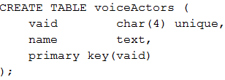

**Functional Dependencies**

vaid 🡪 name

**Sample Data**

|  |  |
| --- | --- |
| VAID | Name |
| V001 | Trey Parker |
| V002 | Matt Stone |
| V003 | Adrien Beard |
| V004 | Issac Hayes |

**CharactersVoice**

Purpose: This table is used to store information about which characters the voice actors provide their voices for

**Create Statement**

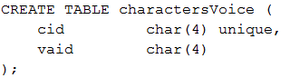

**Functional Dependencies**

cid 🡪 vaid

**Sample Data**

|  |  |
| --- | --- |
| CID | VAID |
| C001 | V001 |
| C002 | V002 |
| C003 | V002 |
| C004 | V001 |
| C005 | V001 |
| C006 | V001 |
| C007 | V002 |
| C008 | V003 |
| C009 | V004 |

**CharacterTraits**

Purpose: This table is used to store information about what defining character trait each character has

**Create Statement**

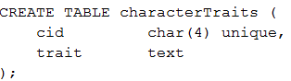

**Functional Dependencies**

cid 🡪 trait

**Sample Data**

|  |  |
| --- | --- |
| CID | Character Trait |
| C001 | Leader |
| C002 | Jew |
| C003 | Poor |
| C004 | Fat Ass |
| C005 | Gay |
| C006 | Lorde |
| C007 | Constantly Grounded |
| C008 | Only Black Kid |
| C009 | Chef |

**Episodes**

Purpose: This table is used to store information the episodes the show has aired. It keeps track of the episode number, which season it was it, what episode number it was in the season, the name of the episode and the original air date.

**Create Statement**

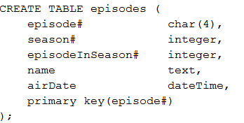

**Functional Dependencies**

episode# 🡪 season#, episodeInSeason#, name, airdate

**Sample Data**

|  |  |  |  |  |
| --- | --- | --- | --- | --- |
| Episode# | Season# | episodeInSeason# | Name | airDate |
| 66 | 5 | 1 | It Hits the Fan | 06-20-2001 |
| 137 | 9 | 12 | Trapped in the Closet | 11-16-2005 |
| 161 | 11 | 8 | Le Petit Tourette | 10-03-2007 |
| 215 | 15 | 6 | City Sushi | 06-01-2011 |

**ThingsParodied**

Purpose: This table is used to store the things that have been parodied in South Park. South Park has parodied everything from celebrities, religions, politics, and mental disorders and we need a place to store all of them.

**Create Statement**

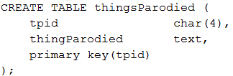

**Functional Dependencies**

tpid 🡪 thingParodied

**Sample Data**

|  |  |
| --- | --- |
| Tpid | ThingParodied |
| P001 | Chicago Hope |
| P002 | Tom Cruise |
| P003 | Scientology |
| P004 | R. Kelly |
| P005 | Tourettes |
| P006 | Asian Accents |
| P007 | Split Personality Disorder |
| P008 | Horror Movies |
| P009 | Psycho |

**ParodiedInEpisodes**

Purpose: This table is used to store information about what was parodied in each episode.

**Create Statement**

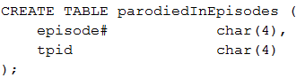

**Functional Dependencies**

tpid🡪 Episode#

**Sample Data**

|  |  |
| --- | --- |
| Tpid | Episode# |
| P001 | 66 |
| P002 | 137 |
| P003 | 137 |
| P004 | 137 |
| P005 | 161 |
| P006 | 215 |
| P007 | 215 |
| P008 | 215 |
| P009 | 215 |

**CharactersInEpisodes**

Purpose: This table is used to store what characters appeared in each episode.

**Create Statement**

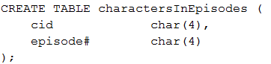

**Functional Dependencies**

cid, episode# 🡪

**Sample Data**

|  |  |
| --- | --- |
| Cid | Episode# |
| C001 | 66 |
| C002 | 66 |
| C003 | 66 |
| C004 | 66 |
| C005 | 66 |
| C007 | 66 |
| C001 | 137 |
| C002 | 137 |
| C003 | 137 |
| C004 | 137 |
| C006 | 137 |
| C007 | 137 |
| C008 | 137 |
| C001 | 161 |
| C002 | 161 |
| C003 | 161 |
| C004 | 161 |
| C005 | 161 |
| C007 | 161 |
| C001 | 215 |
| C002 | 215 |
| C003 | 215 |
| C004 | 215 |
| C007 | 215 |
| C008 | 215 |

**CharacterCurses**

Purpose: This table is used to store the number of times each character curses per episode

**Create Statement**

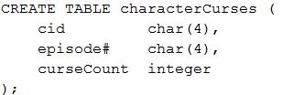

**Functional Dependencies**

cid, episode#, curseCount🡪

**Sample Data**

|  |  |  |
| --- | --- | --- |
| Cid | Episode# | CurseCount |
| C001 | 66 | 18 |
| C002 | 66 | 15 |
| C003 | 66 | 14 |
| C004 | 66 | 25 |
| C005 | 66 | 4 |
| C006 | 66 | 5 |
| C007 | 66 | 6 |
| C009 | 66 | 10 |
| C001 | 137 | 4 |
| C002 | 137 | 5 |
| C003 | 137 | 2 |
| C004 | 137 | 4 |
| C006 | 137 | 3 |
| C001 | 161 | 7 |
| C002 | 161 | 6 |
| C003 | 161 | 2 |
| C004 | 161 | 94 |
| C001 | 215 | 3 |
| C002 | 215 | 6 |
| C003 | 215 | 2 |
| C004 | 215 | 5 |
| C005 | 215 | 1 |
| C007 | 215 | 8 |

**CharacterDeaths**

Purpose: This table is used to store information about what was parodied in each episode.

**Create Statement**

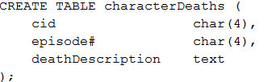

**Functional Dependencies**

cid, episode#, description 🡪

**Sample Data**

|  |  |  |
| --- | --- | --- |
| Cid | Episode# | Description |
| C003 | 66 | Vomited his intestines out after getting the plague |

**SchoolPosition**

Purpose: This table is used to store what positions are available in the school

**Create Statement**

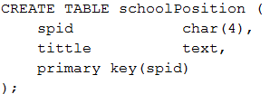

**Functional Dependencies**

spid 🡪 episode#, description

**Sample Data**

|  |  |
| --- | --- |
| Spid | Tittle |
| S001 | 3rd Grade Teacher |
| S002 | 4th Grade Teacher |
| S003 | Chef |

**CharacterSchoolPosition**

Purpose: This table is used to store what position in the school a character holds

**Create Statement**

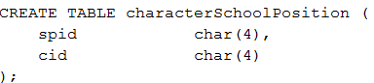

**Functional Dependencies**

spid 🡪 cid

**Sample Data**

|  |  |
| --- | --- |
| Spid | Cid |
| S001 | C005 |
| S002 | C005 |
| S003 | C009 |